From: https://www.revolver.news/2021/10/meet-ray-epps-the-fedhttps://www.revolver.news/2021/10/meet-ray-epps-the-fed-protected-provocateur-who-appears-to-have-led-the-very-first-1-6-attack-on-the-u-s-capitol/
Via: https://www.zerohedge.com/political/fed-protected-man-identified-mystery-instigator-j6-capitol-breach
Keywords: Ray Epps, James Ray Epps, Stewart Rhodes,
Date: TUESDAY, OCT 26, 2021
'Fed-Protected' Man Identified As Mystery Instigator Of J6 Capitol Breach

The story of the mystery man, Ray Epps, featured in Rep. Massie’s video above is in fact far more shocking than even the good Congressman implies in the hearing. It’s a story so strange, and so scandalous at every turn, that it threatens to shatter the entire official narrative of the “Capitol Breach” and expose yet another dimension of proactive federal involvement in the so-called “insurrection” of January 6th.
If Revolver News’s previous reporting points to a proactive role of the federal government in relation to the conspiracy cases against Oath Keepers and Proud Boys, the Ray Epps story that follows suggests a similar, yet more egregious, explicit, direct and immediate degree of federal involvement in the breach of the Capitol itself.
Here is a transcript of Thomas Massie’s exchange with the Attorney General, just in case you skipped past the video above.
Rep. Massie: As far as we can determine, the individual who was saying he’ll probably go to jail, he’ll probably be arrested, but they need to go into the Capitol the next day, is then directing people into the Capitol the next day, is then the next day directing people to the Capitol. And as far as we can find. You said this is one of the most sweeping in history. Have you seen that video, or those frames from that video?
AG Garland: So as I said at the outset, one of the norms of the Justice Department is to not comment on pending investigations, and particularly not to comment on particular scenes or particular individuals.
Rep. Massie: I was hoping today to give you an opportunity to put to rest the concerns that people have that there were federal agents or assets of the federal government present on January 5 and January 6. Can you tell us, without talking about particular incidents or particular videos, how many agents or assets of the federal government were present on January 6, whether they agitated to go into the Capitol, and if any of them did?
AG Garland: So I’m not going to violate this norm of, uh, of, of, of, the rule of law.
[Looks down and away]
I’m not going to comment on an investigation that’s ongoing.
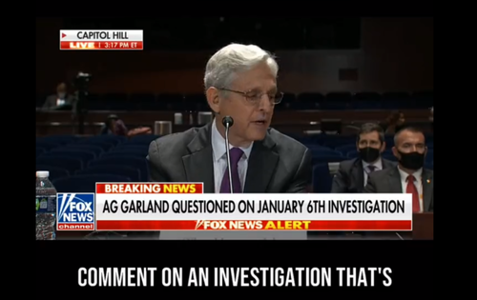
There is good reason why AG Garland ran from Massie’s question faster than he could find words — and why he couldn’t even keep eye contact as he was dodging Massie’s gaze.
After months of research, Revolver’s investigative reporting team can now reveal that Ray Epps appears to be among the primary orchestrators of the very first breach of the Capitol’s police barricades at 12:50pm on January 6. Epps appears to have led the “breach team” that committed the very first illegal acts on that fateful day. What’s more, Epps and his “breach team” did all their dirty work with 10 minutes still remaining in President Trump’s National Mall speech, and with the vast majority of Trump supporters still 30 minutes away from the Capitol.
Secondly, Revolver also determined, and will prove below, that the the FBI stealthily removed Ray Epps from its Capitol Violence Most Wanted List on July 1, just one day after Revolver exposed the inexplicable and puzzlesome FBI protection of known Epps associate and Oath Keepers leader Stewart Rhodes. July 1 was also just one day after separate New York Times report amplified a glaring, falsifiable lie about Epps’s role in the events of January 6.
Lastly, Ray Epps appears to have worked alongside several individuals — many of them suspiciously unindicted — to carry out a breach of the police barricades that induced a subsequent flood of unsuspecting MAGA protesters to unwittingly trespass on Capitol restricted grounds and place themselves in legal jeopardy.
Corroborating Ray Epps’s Identity
Identifying the individual in Thomas Massie’s video as Ray Epps was a surprisingly quick and easy task for the Internet.
It took less than a week after January 6 for online researchers to track down Epps down and confirm his identity. Researchers uncovered his personal Facebook profile, where Epps shared his life story on Mark Zuckerberg’s social media app, under his real name.
On Facebook, Epps posted photos of himself boating, on horseback, and bear-hunting with a crossbow.

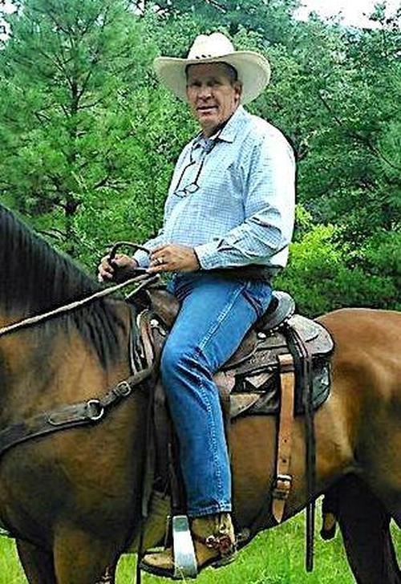
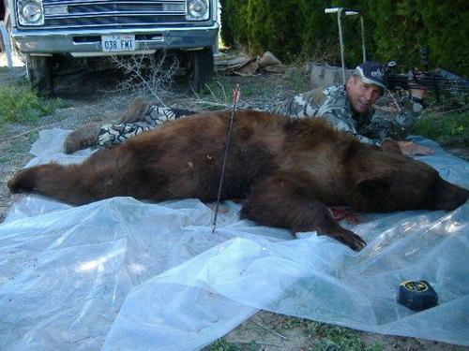
That’s a pretty big bear to hunt with a crossbow. And in many respects, Epps is quite an impressive figure. He served in the US Marines and ultimately worked his way up to full Marine Sergeant, according to his previous public title “SGT USMC” (Sergeant, US Marine Corp) and his private Facebook nostalgic musings.
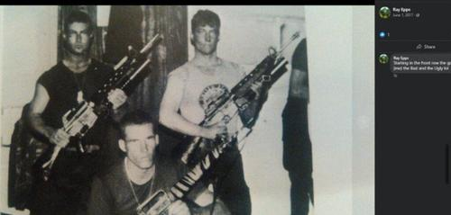Description at right:
Ray Epps
Starting in the front row the good
(me) the Bad and the Ugly lol
Researchers went on to locate Epps’s ranch in Arizona, his events business, his private holding company, along with every publicly discoverable record imaginable. They even found his Facebook likes, religious affiliation, and preferred insurance agents and plumbing services, which we’ll avoid reporting in the interest of sparing unnecessary private details.
Epps, who grew up in Arizona and still lives there today, was contacted directly by local newspaper Arizona Central on January 11 — less than a week after January 6, and just three days after Epps was added to the FBI Most Wanted list, a detail upon which we will elaborate later on in this report.
AZ Central, which published its contemporaneous article on Epps under the original headline, In video, Trump supporter says, ‘We need to go into the Capitol’, first confirms his attendance at the Capitol protest:
A Queen Creek man who acknowledges he was in Washington, D.C., for last week’s rally by President Donald Trump also appears to be shown in videos taken the night before talking about plans to go inside the U.S. Capitol.
In one video that has been widely viewed on Twitter, he can be heard saying, “I don’t even like to say it because I’ll be arrested. I’ll say it. We need to go into the Capitol.”
Ray Epps told The Arizona Republic in a brief telephone interview Monday that he had traveled to the capital for the event, and that he had been advised by an attorney not to speak about it.
“I think the truth needs to get out,” he said.
A video online appears to show him saying, “We’re here to defend the Constitution” and “We need to go into the Capitol.
Epps didn’t stop at simply confirming his presence at the Capitol. Epps effectively corroborated on record that he was the exact same man telling Trump supporters they needed to go inside the Capitol.
Asked about it, he first told The Republic he would need to see the video. When read a transcript of the comments, he said, “The only thing that meant is we would go in the doors like everyone else. It was totally, totally wrong the way they went in.” [AZ Central]
The video below compiles shortened versions of five separate exchanges apparently involving Epps at various hours during the night of January 5 and afternoon of January 6.
As you process the video above and the information to follow, it is important to keep in mind: Ray Epps is a free man. He has never been arrested or charged. Nearly 10 months after January 6, the FBI and Justice Department still refuse to comment on whether Epps has ever been served a search warrant.
But we do know that at least rank-and-file FBI investigators were intensely interested in Ray Epps in the immediate aftermath of January 6.
By January 8, the FBI Capitol Violence Most Wanted List featured a big fat friendly face shot of Ray Epps. The FBI’s Washington Field Office, in a tweet the same day, called for the public’s help in identifying Epps. Epps, dressed in full camo with a bright red “Trump” hat, is the FBI’s “Suspect 16” in the bottom-left quadrant of both images reproduced below:
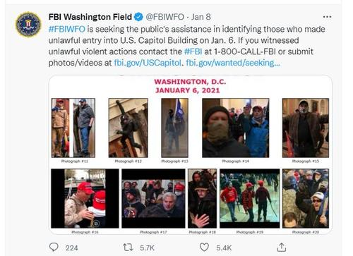
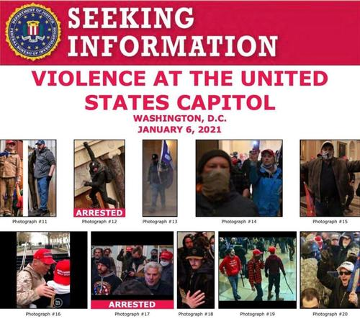
For your edification, we matched FBI Suspect Photo #16 to the timestamp 0:48 of the full barricade breach source video:
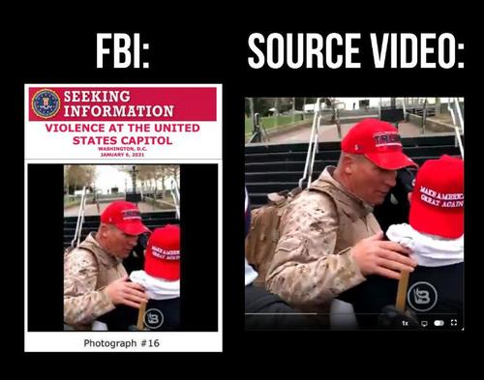
There are currently 486 suspects in the FBI’s Capitol Violence Most Wanted list. The fact that Ray Epps was one of the first 20 suspects the FBI ever publicly featured on its “be on the lookout” boards and “Most Wanted” lists reveals just how high a priority the FBI’s rank-and-file investigators considered Epps to be.
So to recap, on January 8, the FBI begged the public’s help to identify the mysterious “Person #16.”
Then, a funny thing happened: the public actually delivered.
Initially, swarms of left-wing researcher accounts, Antifa groups, and partisan non-profits leapt into Crowdsourced Internet Detective mode. They assigned Epps’s identity various hashtags and tracked his movements throughout January 5-6. The primary three hashtags assigned to Epps were:
- #CrowdControl, because of the way Epps was always controlling every crowd, he was a part of [this hashtag] on both January 5 and January 6;
- #FedBoomer, because of the shocking video (analyzed below) of Epps being shouted down as a “Fed” by Trump supporters for proposing to enter the Capitol [he was a part of this hashtag]; and
- #BigMagaCamo, which came to be Epps’s final, neutral descriptor name. It is under the #BigMagaCamo moniker that virtually all left-wing databases, shared Google spreadsheets and multimedia archives retain most of their Ray Epps information.
Within days of the riot at the Capitol, archives quickly swelled with videos and images of [Ray] Epps.
Ray Epps played two roles in virtually every encounter during his Commando Capitol Tour on January 6.
Click here to read [about these two roles and] the rest of the report...

A search for Ray Epps shows 14 results.

